**OLABISI ONABANJO UNIVERSITY**

College of Engineering & Environmental Studies,

Ibogun Campus.

**DEPARTMENT OF MECHANICAL ENGINEERING**

**Mechanical Engineering Programme**



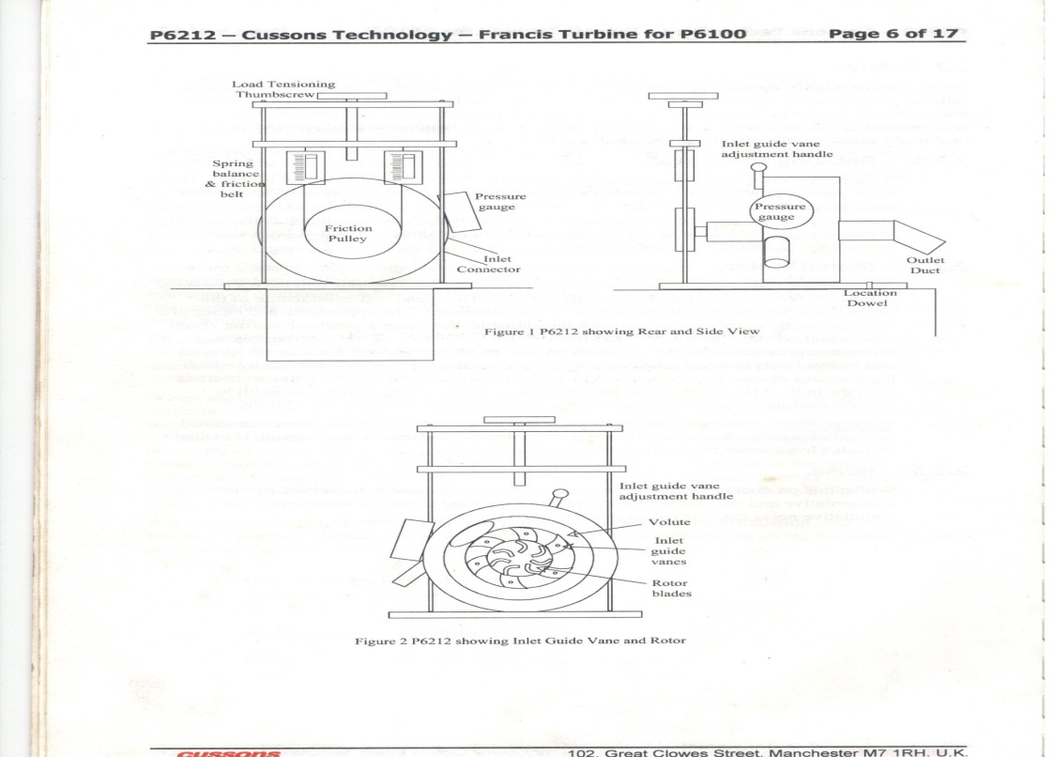

**THERMODYNAMICS/HEAT & MASS TRANSFER LABORATORY MANUAL**

**300LEVEL**

 **OLABISI ONABANJO UNIVERSITY,**

**MECHANICAL ENGINEERING PROGRAMME,**

**CEES, IBOGUN CAMPUS.**

**ENGINEERING THERMODYNAMICS**

**EXPERIMENT: 1**

**TITLE: MEASUREMENT OF TURBINE PERFORMANCE**

**INTRODUCTION:**

Francis Turbine is a small unit designed for the laboratory experiment to be mounted on a Hydraulic Bench. It allows the student to study the basic characteristics of the Francis Turbine but with limited efficiency and operational accuracy.

The Turbine used the water pumping capability of the Hydraulic bench together with its volumetric flow measurement as part of its experimental capability. The Francis Turbine is designed to sit on the locations dowels of the Hydraulic bench and to take its water supply from the sump tank through the flexible hose available on the bench to the top. The water drains into the main volumetric tank of the bench, which is graduated to allow the volume of flow to be measured with time.

The Turbine comprises of a PVC stator block screwed to a mounting plate suitable for location on the top face of the Hydraulic bench. The stator block has a clear Perspex cover to allow the water flow to be observed. Water enters the station volute from an inlet hose connector and is directed from the volute through six (6) inlet guide vanes into the rotor vanes. The rotor vane extracts energy from flow passing power through the shaft, which runs in two ball bearings.

**Objectives:** The objectives of the experiment are to determine;

1. The mass flow rate of the fluid
2. The pressure of the fluid
3. The mechanical power, Wm
4. The Turbine Hydraulic Efficiency (eff. T)
5. The effect of guide vane setting on Turbine performance.

**Equipment/Apparatus:**

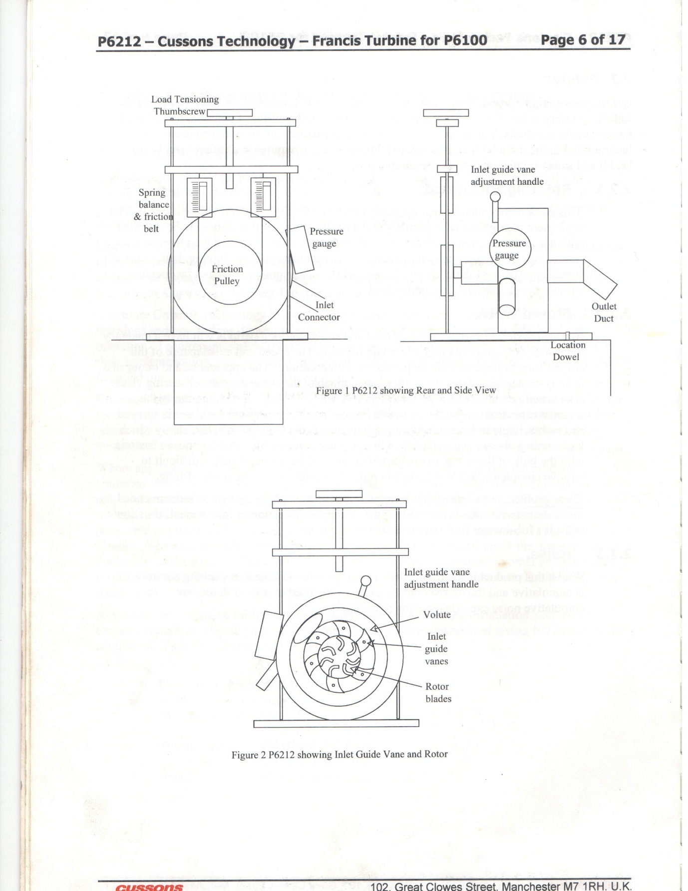

Figure 1.1: Rear view Francis Turbine



Figure 1.2: Side view Francis Turbnie



Figure 1.3: Francis Turbine Inlet Guide Vane and Rotor

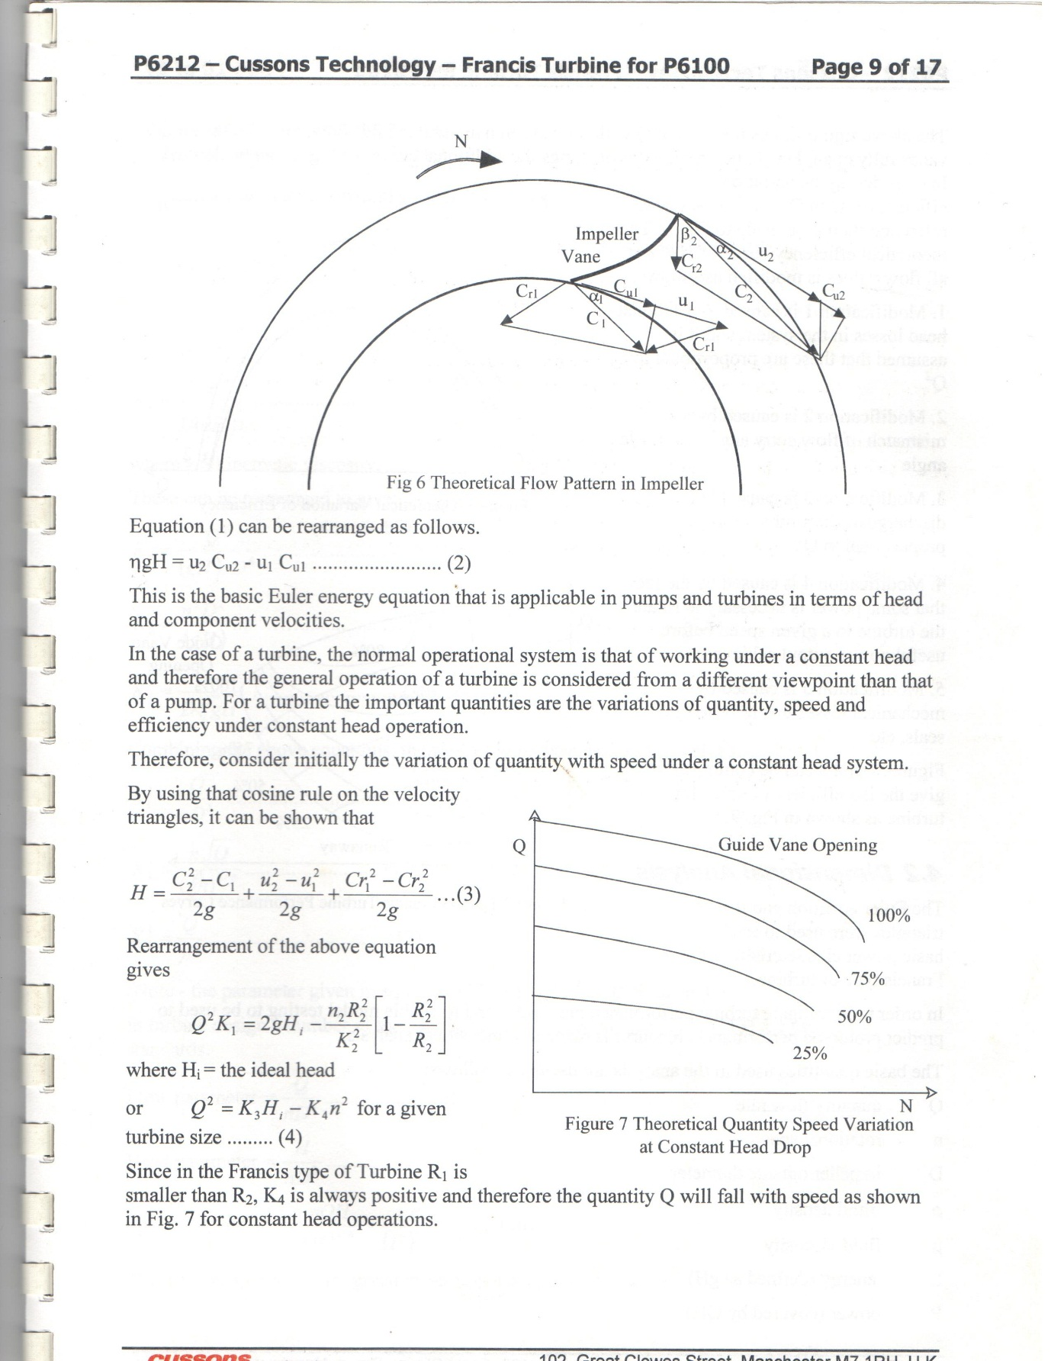

Figure 1.4: Theoretical flow pattern in impeller



Figure 1.5: Theoretical Quantity Speed Variation at Constant Head Drop

**Procedure**:

Mount the base plate of the Francis Turbine on the work surface of the Hydraulic bench with the outlet duct pointed towards the measuring (volumetric) tank. Connect the feed hose from the sump tank to the inlet connector of the Francis Turbine gently with adequate care. It should not be forced on.

Switch on the Hydraulic bench pump and open the flow control tap on the Hydraulic bench checking that the Francis Turbine is starting to rotate smoothly.

The inlet guide vane angle can be adjusted by moving the lever on the guide vane drive ring, and observing the rotation of the guide vanes through the Perspex from cover. The angle of the guide vanes can be observed from the scale on the Turbine housing.

The analysis of the Turbine operation showed that the optimum Turbine design is achieved where the inlet energy of the water is extracted by extracting the centripetal and forward velocity of the inlet water. With the inlet guide vane angle set at a fixed (specified) position for the duration of the experiment, the characteristics of the water outlet flow can be examined.

1. Set the inlet guide vane to a suitable positioned (to be given by the instructor). Observed the velocity and rotation of the outlet water.
2. (ii) Measure the pressure of the fluid at the inlet guide vane angle.
3. (iii) The reading should be repeated at alternative guide vane angle setting at 15o, 20o, 25o, 40o, 45o, and 50o
4. (iv) Collect the specified quantity of litres, (eg 5L, 10L, 15L……….. ) of water from the Francis Turbine outlet into the weighing (volumetric) tank and record the time taken in seconds.
5. (v) Repeat the same quantity of fluid three (3) times and calculate the average time (tav) taken.
6. (vi) Record the head (H) of the water available to the Turbine, the outlet diameter of the Francis Turbine, the speed and the torque.

The result should be tabulated as shown below

Table 1.1: Table of results

|  |  |  |  |  |  |  |  |
| --- | --- | --- | --- | --- | --- | --- | --- |
| S/N | Time (secs)  T1(s) T2(s) T3(s) Tav(s) | Qty . Q (Lt) | Flow rate m3/s | Setting Degree | Pressure P (bar) | Head H (mm) |  |
|  |  |  |  |  |  |  |  |
|  |  |  |  |  |  |  |  |

Speed = -------rpm, Torque = ------- Nm, Turbine outlet Diameter (mm) = ------

**Note**: The Instructor in charge must endorse your readings, within one hour after taken the readings, without which your reading and reports are invalid.

**Results and calculation**

1. Mechanic Power Wm



Where N = Speed in rpm

T = Torque in Nm

**Exercises**

1. (i) Plot a graph of quantity Q (m3) against Time Tav (Secs)

(ii) Determine the slope of your graph in (i) above

1. (i) Estimate the mass flow rate and comment on the results.

(ii) Compare your slope with the estimated flow rate.

1. Calculate the co efficient of discharge based on your graph slope in 1 (ii) above.
2. Calculate (i) the mechanical power of the turbine

(ii) The turbine hydraulic efficiency

1. Name the types of hydraulic turbine and their applications
2. What are the four (4) possible losses in the turbine
3. Mechanical energy is a form of energy that can be converted to mechanical work completely and directly by a mechanical device.

What are the three forms of mechanical energy that can be converted to mechanical work directly by a mechanical device?

**EXPERIMENT 2**

**TITLE: MECHANICAL EQUIVALENT OF HEAT**

**AIM/OBJECTIVE**: To determine the mechanical equivalent of heat and verify the first law of thermodynamics.

**EQUIPMENT/APPARATUS:** Electric motor, Calorimeter, friction belt, revolution counter, weight hanger, weight, spring balance, glass Thermometer.

**INTRODUCTION:**

Mechanical equivalent of heat essentially consists of an electric motor, which drives a water filled calorimeter with a rotary motion which is opposed by a friction belt around its periphery. The apparatus is shown in figure below. The motor is a main operated ac geared unit, which is housed in an enclosure and drives with the calorimeter shaft through a speed reducing V belt. A sturdy twin bearing pedestal from the top of the enclosure support the calorimeter shaft. A cam on the shaft operates a revolution counter. A safety guard is provided around the belt drive.

The calorimeter which is design to hold water is fabricated from brass and is attached to the shaft by a gunmetal drum holder. The nominal outside diameter of the calorimeter is 6” (152.4 mm), but the precise dimension, which is required for analysis, should be checked by measurement. The calorimeter drum is weighed during manufacture and the weight in grams is engraved on to the face of the drum.

A friction belt is provided together with weights, weight carriers and a spring balance, which form a friction brake, and allow for measurement of the retarding torque. A single pole bracket is used to support the spring balance and also provides a support for clamping a -5 to 500C mercury in glass thermometer, which is used to measure the water temperature.

**THEORY:**

First law of thermodynamics is the principle of the conservation of energy when applied to a closed system in which only energy in the form heat or work can cross the boundary of the system. i.e Q = W

If, a system does not follow a cycle but undergoes a process, then a corollary of the first law is that: Q γ W

Which state as “There exists a property of a closed system such that a change in its value is equal to the difference between the heat received and the work done during any change of state.”

The property is called an Internal Energy U and it is represented with equation

Q –W = ∆U (called Non Flow Energy Equation NFEE)

**APPLICATION:**

Appling the first law of thermodynamics to Mechanical Equivalent of Heat requires a number of definitions to be made and some assumptions simplifying.

System- Let the system be defined as the calorimeter drum, the band brake and the water contained in the drum.

Work Done- Work is done on the system by the electric motor which impart relative movement between the calorimeter drum and the band brake. The band brake grips the drum and the motor has to overcome the friction force, which is measured by the force that has to be applied to restrain the band brake from rotating.

Restraining Force, F = WL – WS + S

The product of the restrain force and circumference of the drum gives the work done per revolution i.e the restrain force x circumference of the drum = the work done per revolution

W = πDF = πD (WL – WS + S)

And the total work done during the time period is

W = πDFN = πD (WL – WS + S)N

Where N is the number of revolutions.

Heat Transfer- If heat transfer provided the temperature difference between the system is very small, then the heat transfer to the surrounding will also be very small.

**Diagram**

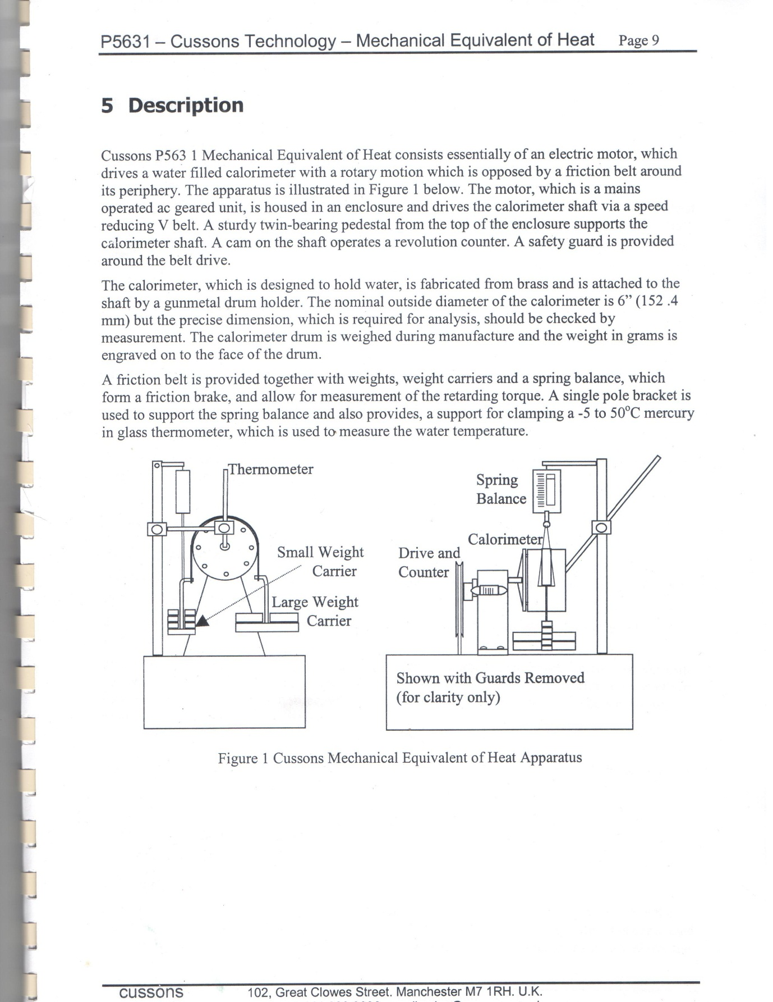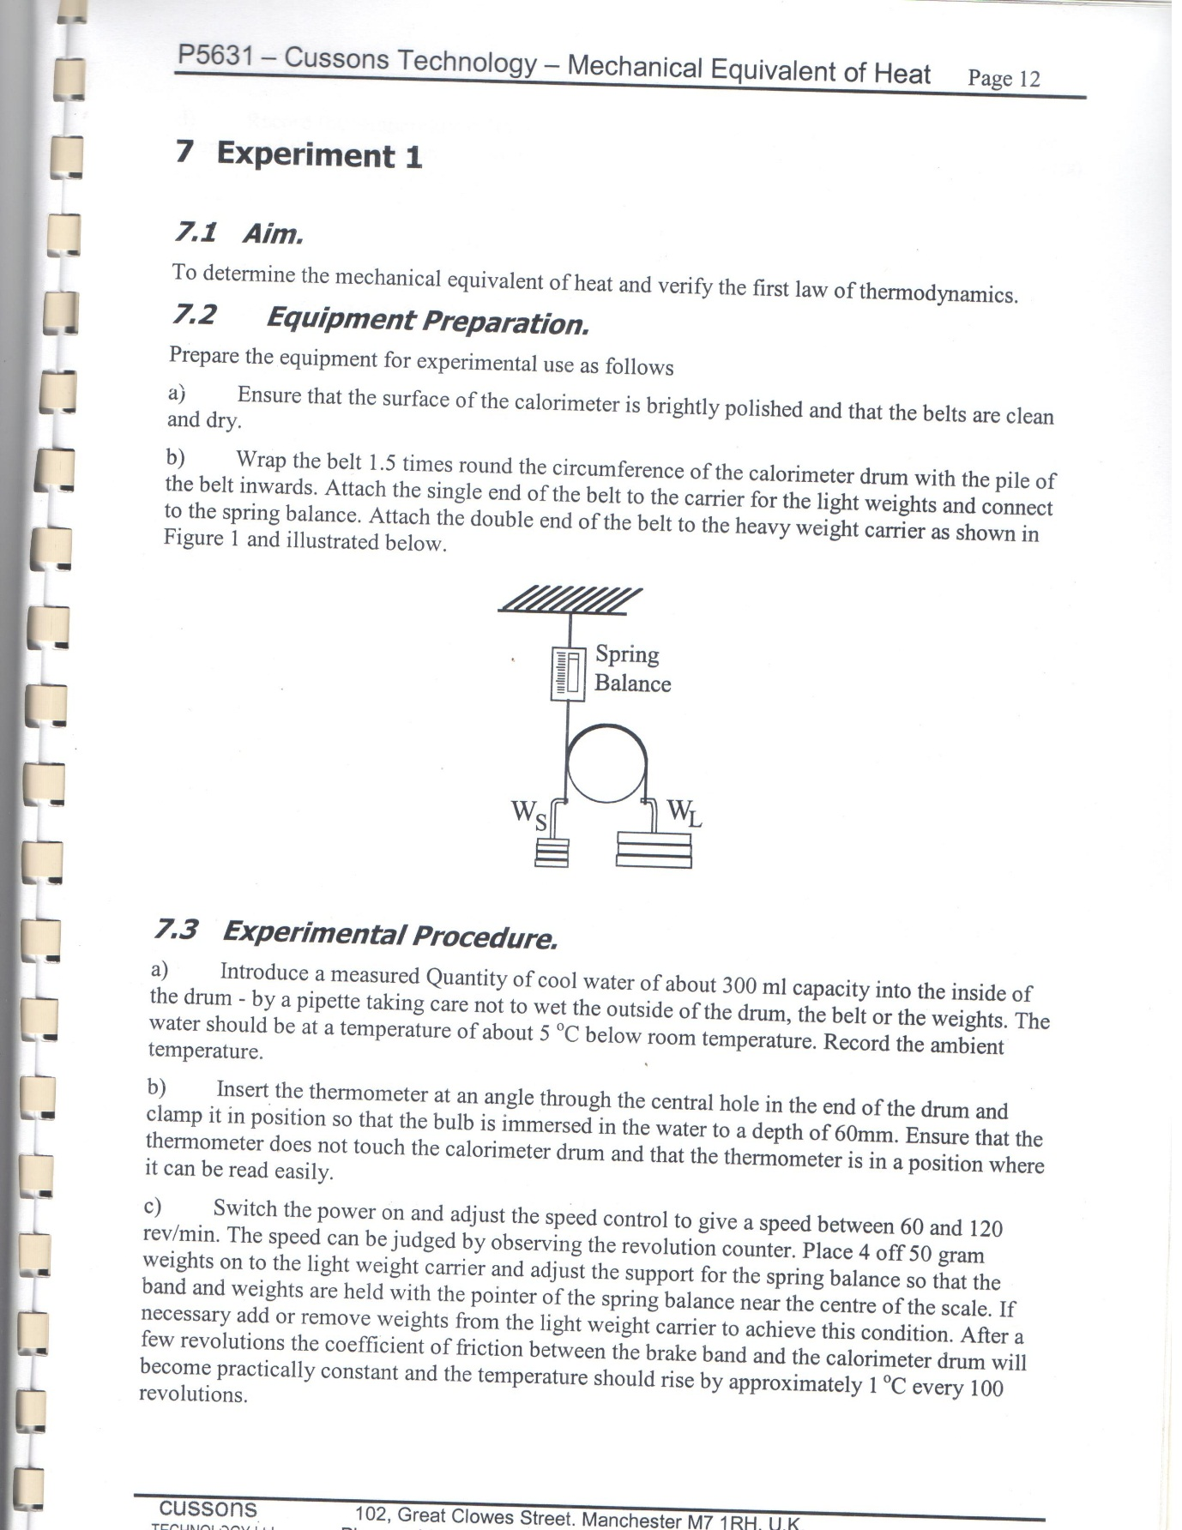

Figure 2.1: Mechanical Equivalent of Heat Apparatus

**PROCEDURE:**

Equipment preparation:

(a) Ensure that the surface of the calorimeter is brightly polished and that the belts are clean and dry.

(b) Wrap the belt 1.5times round the circumference of the calorimeter drum with the pile of the belt inwards. Attach the single end of the belt to the carrier for the light weights and connect the spring balance. Attach the double end of the belt to the heavy weight carrier as shown in the diagram below.

(i) Introduce a measured quantity of cool water of about 300ml capacity into the inside of the drum by a pipette taking care not to wet the outside of the drum, the belt or the weights. The water should be at a temperature of about 50C below room temperature. Record the ambient temperature.

(ii) Insert the thermometer at an angle through the central hole in the end of the drum and clamp it in position so that the bulb is immersed in the water to a depth of 60mm. Ensure that the thermometer does not touch the calorimeter drum and that the thermometer is in a position where it can be read easily.

1. Switch the power on and adjust the speed control to give a speed between 60 and 120 rev/min. The speed can be judged by observing the revolution counter. Place 4 off 50gram weights on the light weight carrier and adjust the support for the spring balance so that the band and weights are held with the pointer of the spring balance near the centre of the scale. If necessary add or remove weights from the light weight carrier to achieve this condition. After a few revolutions the coefficient of friction between the brake and the calorimeter drum will become practically constant and the temperature should rise approximately 10C every 100 revolution.
2. Record the temperature of the water, the number of revolutions shown on the revolution counter and the spring balance reading. Repeat these readings either once per minute or every 100 revolutions to suit your preference. Continue the experiment until the water temperature is 50C higher than the room temperature, again record the ambient temperature.
3. Record the value of the large weights and small weights including the weights of the carriers.

**RESULTS AND ANALYSIS**

Table 2.1: Table of results

|  |  |  |  |  |  |  |  |  |
| --- | --- | --- | --- | --- | --- | --- | --- | --- |
| S/N | 1 | 2 | 3 | 4 | 5 | 6 | 7 | 8 |
| Revolution Counter Reading |  |  |  |  |  |  |  |  |
| Water Temperature 0C |  |  |  |  |  |  |  |  |
| Spring Balance |  |  |  |  |  |  |  |  |
| Ambient Temperature 0C |  |  |  |  |  |  |  |  |
| Large Weights and Carrier Kg |  |  |  |  |  |  |  |  |
| Small Weights and Carrier g |  |  |  |  |  |  |  |  |
| Mass of water g |  |  |  |  |  |  |  |  |
| Specific heat of water J/g0C | 4.1855 |  |  |  |  |  |  |  |
| Mass of Calorimeter g |  |  |  |  |  |  |  |  |
| Specific heat of Calorimeter | 0.368 |  |  |  |  |  |  |  |

**EXERCISES**

1. Select from the table of results those readings, which cover a range of at least 500 revolutions during which time the water temperature rose from below the mean ambient temperature to above the mean ambient temperature.
2. Using a consistent set of units calculate

(a) the mechanical work done from

     Work Done = (WL – WS + S) N πD

(b) the heat generated from

     Heat Generated = MH2O CH2O McalCcal)∆T

(c) the mechanical equivalent of heat from

     J = Work Done/Heat Generated

NOTE: Ensure that the Calorimeter is empty and dry before storage. Remove the belt from the apparatus and wrap it in paper for storage. Never use any hard material to clean the surface of the Calorimeter.

**EXPERIMENT 3**

**TITLE: THERMAL FLUID LABORATORY**

**INTRODUCTION**

Flow in closed conduits is an extremely important area of study due to it most common way of transporting liquids. Crude oil and its components are moved about in a refinery and across the country by pumping them through pipes, water in the homes and industries is transported to various parts of the house through pipes, heated and air-conditioned air are distributed to all parts of a dwelling in circular and/or rectangular ducts. It should be recall that flow in a duct can be either laminar or turbulent. When laminar flow exists, the fluid flow smoothly through the duct in layer is called laminae. A fluid particle in one layer stays in that layers. When turbulent flow exists, flowing fluid particles move about the cross section. Eddies and vortices are responsible for the mixing action such eddies and vortices do not exist in laminar flow.

The criterion for distinguishing between laminar and turbulent flow is the observed mixing action. Experiments have shown that laminar flow exists when the Reynolds number is less than 2100: Re = (ρVD/μ) = (VD/ν)‹2100 (laminar flow). V = (Q/A) = (4Q/πD2)

Where V is the average velocity of the flow, D is the characteristic dimension of the duct cross section. For circular ducts, D is usually taken to the inside diameter, for noncircular cross sections, D is usually taken to be the hydraulic diameter.

The optimization process involves derivation of equation for modelling a system subject to certain constraints, and then taking the derivative of that equation in order to minimize a pressure drop or to minimize the installed cost of a pipeline.

An optimization problem seeks to minimize or maximize a specific variable that help to describe a system. For example, we might have a piping system in which we seek to minimize the pressure drop by using an optimum pipe diameter; we may also want to locate a filter within a duct such that the installed cost is a minimum. An optimization process formulation involves several features like derivation of an objective function/equation and differentiates with respect to one of the variables. The objective function in many cases contains terms that are interrelated and may be necessary to have additional equations in order to solve the problem. The additional equations are referred to as the constraint equations. The objective function is said to be solved subject to the constraints. Some problems may not have constraints; therefore, we would have an unconstrained optimization problem. Use the Microsoft Excel software to proffer solution to the following designs, showing all the necessary details and diagrams where necessary.

**PIPING SYSTEMS**

Q1. A 4-nominal schedule 40 pipe conveys castor oil (ρ=960kg/m3, μ= 650x10-3 N-s/m2, 4-nom sch 40 ID=D= 10.23cm, A= 82.19cm2, wire iron ε= 0.0046cm) at a flow rate of 0.012m3/s. The pipe is made of asphalt-coated cast iron and is 100m long. Determine the pressure drop experience by the fluid.

Q2. Chloroform flows at a rate of 0.01m3/s through a 4-nominal schedule 40 wrought iron pipe (ρ=1.47(1000)kg/m3, μ= 0.53x10-3 N-s/m3, 4-nom sch 40 D= 10.23cm, A= 82.19cm2, wrought iron ε= 0.012cm). The pipe is laid out horizontally and is 250m long. Calculate the pressure drop of the chloroform.

Q3. A 6-nominal schedule 80 cast iron pipe is 3.435km long. It is to convey octane (ρ=701kg/m3, μ=051x103 N-s/m3, 4-nom sch 80 ID=D= 14.64cm, A= 168.3cm2, cast iron ε= 0.025cm). The available pump can provide a pressure drop of 172.32kPa. Determine the expected flow rate of octane in the pipe.

Q4. A PVC plastic pipeline is to convey 50 litres per second of ethylene glycol over a distance of 2000m (ρ=701kg/m3, μ=051x103 N-s/m2, plastic tubing ε= smooth =0cm). The available pump can overcome a frictional loss of 200kPa. Select schedule 40 size for the pipe.

Q5. Air flows through a horizontal duct that is 3m long. The duct is rectangular (30 cm x 15 cm) and is made of galvanized sheet metal. Air flows through the duct at a velocity of 6.1 m/s. Determine the pressure drop (pressure loss in terms of a head of water in centimetre) in the duct. (Air ρ=1.17kg/m3, μ= 18x10-6 N-s/m2, galvanized sheet ε= 0.00015m).

**OPTIMIZATION PROCESS**

Q6. A factory would like to install insulation around a pipe that is carrying a heated fluid, due to space limitations, the outside diameter of the insulation D2 cannot exceed 12 cm. On the one hand, they would like to install as large a pipe as possible so that the cost of pumping the fluid is not excessive. On the other hand they would like to use as thick an insulation as possible to reduce the heat loss. The cost of pumping the fluid through a pipe is given by Cp= (3x10-6/D15) where D1 is in m, and the cost is in Naira/year. The cost of heating the fluid is given by Ch= (9/t) in which t is the insulation thickness (t= D2-D1) in meters, and cost is again in Naira/year.

a. Write the equation for total cost, the constraints is D2= 12cm.

b. Differentiate the cost equation and set it equal to zero.

c. Solve for the diameter D1.

Q7. Linseed oil (ρ= 930kg/m3, μ= 33.1x10-3 Pa.s) is to be pumped from a tank to a bottling machine. The machine can fill and cap 30 two-litre bottles in one minute. Determine the optimum size for the insulation. Use the following parameters: C2 =N0.05/(kW.hr), C1 = N820/m2, t = 7000 hr/year, F=6.75, n = 1.2, a = 1/(10yr), b= 0.01,η= 0.75, PVC schedule 40 pipe. Dopt={40fm3C2t/n(a+b)(1+F)C1ηπ2ρ2}(1/n+5)

Q8. A commercial steel (ε= 0.0046 cm) pipeline is to be installed in a return line from a pump to the condenser of an air conditioner in which the rejected heat is used to preheat water (ρ=1000 kg/m3, μ= 0.89x10-3N.s/m2) and reduce energy consumption. Water is to be conveyed at a flow rate of 3.8 litre/sec. Determine the optimum economic pipe size for the installation given by:C2=N0.04/(kW.hr), C1=N700/m2, t=6000 hr/yr, F=7.0, n=1.2, a=1/(7yr), b=0.01, η=0.75. Dopt={40fm3C2t/n(a+b)(1+F)C1ηπ2ρ2}(1/n+5)

Q9. An axial flow fan is to be installed in a 1-m inside diameter duct. The fan is to deliver 400 m3/min of air (ρ= 1.185 kg/m3). The Bernoulli equation applied to the duct shows that the static pressure drop over the total length (expressed in column of liquid units) is 3.8 cm of water. Determine the air velocity, the static pressure, the kinetic pressure, the total pressure in millimetre of water, the power input and the power output required for 80% efficiency axial flow fan.

**HEAT TRANSFER**

Q10. A 1-m tall vertical wall of a kitchen oven consists of tree materials placed in series- sheet metal, insulation and sheet metal (k= 43W/m.k, L= 0.001m ). The sheet metal pieces are made of carbon steel and are 1mm thick, while the glass fiber (k=0.035W/m.k, L= 0.04m) insulation is 4 cm thick. Inside the oven, the ait temperature is 2500C and heat is convected to the wall. Sketch the right diagram to show the appropriate conditions and Use Microsoft excel software to determine the heat transferred through the wall if the outside surface is in contact with air at 250C.

(Air properties at 500k are ρ= 0.705 kg/m3, Cp = 1029.5 J/(kg.k), kf=0.04038W/(m.k), v= 37.90x10-6m2/s, α= 0.5564x10-4m2/s, Pr =0.68, Air properties at 300k are ρ=1.177 kg/m3, Cp = 1005.7 J/(kg.k), kf =0.02624W/(m.k), v= 15.68x10-6m2/s, α= 0.22160x10-4m2/s, Pr=0.708). Use the experimentally determined Churchill-Chu equation: Nu = hL/Kf = 0.68 + (0.67Ra1/4/{1+[0.492/Pr]9/16}4/9)

Where Ra = gβ(Ts-T͚)L3‹ 109, 0 ‹ Pr =(ν/α‹͚Infinite) and β=(1/ T͚)=coefficient of thermal expansion.

Assumptions: a. the system is at steady state.

b. Properties of the materials are constant.

c. Air properties are constant and are evaluated at the appropriate temperature,

d. Radiation heat transfer is eglected,

e. Resistance to heat flow within the sheet metal pieces is negligible, so the temperature of each is uniform throughout.

Q11. A horizontally laid 2-nominal schedule 40 steel pipe (k=43.3 w/m.k, OD= 60.34mm, ID=52.52mm) is lagged with fibreglass insulation (k=0.035W/m.k) and is 25mm thick. The pipe conveys steam that maintains the inside surface temperature at 1200C. Air outside the insulation is at 260C. Sketch the right diagram to show the appropriate conditions and Use Microsoft excel software to determine the heat loss through the pipe and insulation.

(Air properties at 26=273=299k=300k are ρ=1.177 kg/m3, Cp = 1005.7 J/(kg.k), kf =0.02624W/(m.k), v= 15.68x10-6m2/s, α= 0.22160x10-4m2/s, Pr=0.708).

Use the experimentally determined Churchill-Chu equation:

Nu = hD/Kf = {0.60 + (0.387Ra1/6/{1+[0.559/Pr]9/16}8/27)}2

where 10-5‹ Ra = gβ(Ts-T͚)L3‹ 1012, 0 ‹ Pr =(v/α‹͚Infinite) and β=(1/ T͚)=coefficient of thermal expansion.

Assumptions: a. The system is at steady state.

b. Properties of the materials are constant. c. Air properties are constant and are evaluated at the temperature of 800C,

d. Radiation heat transfer is neglected.

***PRACTICAL REPORT***

NOTES:

................................................................................................................................................................................................................................................................................................................................................

........................................................................................................................................................................................................................................................................................................................................................................................................................................................................................................................

.................................................................................................................................................................................................................................................................................................................................................................................................................................................................................................

………………………………………………………………………………………………….......................................................…..................................................................................................................................................................……………………………………………………………………………………………………........................................................................................................................................................................................................................……………………………

………………………………………………………………………………………………….......................................................…..................................................................................................................................................................……………………………………………………………………………………………………..............................................................................

……………………………………………………………………………………………………………………………………………………………………………………………………………………………………………………………………………………………………………………………………………………………………………………………………………………………………….......................................................…..................................................................................................................................................................……………………………………………………………………………………………………........................................................................................................................................................................................................................……………………………

………………………………………………………………………………………………….......................................................…..................................................................................................................................................................……………………………………………………………………………………………………........................................................................................................................................................................................................................……………………………

………………………………………………………………………………………………….......................................................…..................................................................................................................................................................……………………………………………………………………………………………………........................................................................................................................................................................................................................……………………………

………………………………………………………………………………………………….......................................................…..................................................................................................................................................................……………

………………………………………………………………………………………........................................................................................................................................................................................................................……………………………

………………………………………………………………………………………………….......................................................…..................................................................................................................................................................……………………………………………………………………………………………………........................................................................................................................................................................................................................……………………………

………………………………………………………………………………………………….......................................................…..................................................................................................................................................................……………………………………………………………………………………………………..............................................................................

………………………………………………………………………………………………….......................................................…..................................................................................................................................................................……………………………………………………………………………………………………........................................................................................................................................................................................................................……………………………

………………………………………………………………………………………………….......................................................…..................................................................................................................................................................……………………………………………………………………………………………………........................................................................................................................................................................................................................……………………………

........................................................................................................................................................................................................................................................................................................................................................................................................................................................................................................................

........................................................................................................................................................................

................................................................................................................................................................................................................................................................................................................................................

........................................................................................................................................................................................................................................................................................................................................................................................................................................................................................................................

.................................................................................................................................................................................................................................................................................................................................................................................................................................................................................................

………………………………………………………………………………………………….......................................................…..................................................................................................................................................................……………………………………………………………………………………………………........................................................................................................................................................................................................................……………………………

………………………………………………………………………………………………….......................................................…..................................................................................................................................................................……………………………………………………………………………………………………..............................................................................

……………………………………………………………………………………………………………………………………………………………………………………………………………………………………………………………………………………………………………………………………………………………………………………………………………………………………….......................................................…..................................................................................................................................................................……………………………………………………………………………………………………........................................................................................................................................................................................................................……………………………

………………………………………………………………………………………………….......................................................…..................................................................................................................................................................……………………………………………………………………………………………………........................................................................................................................................................................................................................……………………………

………………………………………………………………………………………………….......................................................…..................................................................................................................................................................……………………………………………………………………………………………………........................................................................................................................................................................................................................……………………………

………………………………………………………………………………………………….......................................................…..................................................................................................................................................................……………

………………………………………………………………………………………........................................................................................................................................................................................................................……………………………

………………………………………………………………………………………………….......................................................…..................................................................................................................................................................……………………………………………………………………………………………………........................................................................................................................................................................................................................……………………………

………………………………………………………………………………………………….......................................................…..................................................................................................................................................................……………………………………………………………………………………………………..............................................................................

………………………………………………………………………………………………….......................................................…..................................................................................................................................................................……………………………………………………………………………………………………........................................................................................................................................................................................................................……………………………

........................................................................................................................................................................................................................................................................................................................................................................................................................................................................................................................

........................................................................................................................................................................

................................................................................................................................................................................................................................................................................................................................................

........................................................................................................................................................................................................................................................................................................................................................................................................................................................................................................................

.................................................................................................................................................................................................................................................................................................................................................................................................................................................................................................

………………………………………………………………………………………………….......................................................…..................................................................................................................................................................……………………………………………………………………………………………………........................................................................................................................................................................................................................……………………………

………………………………………………………………………………………………….......................................................…..................................................................................................................................................................……………………………………………………………………………………………………..............................................................................

……………………………………………………………………………………………………………………………………………………………………………………………………………………………………………………………………………………………………………………………………………………………………………………………………………………………………….......................................................…..................................................................................................................................................................……………………………………………………………………………………………………........................................................................................................................................................................................................................……………………………

………………………………………………………………………………………………….......................................................…..................................................................................................................................................................……………………………………………………………………………………………………........................................................................................................................................................................................................................……………………………

………………………………………………………………………………………………….......................................................…..................................................................................................................................................................……………………………………………………………………………………………………........................................................................................................................................................................................................................……………………………

………………………………………………………………………………………………….......................................................…..................................................................................................................................................................……………

………………………………………………………………………………………........................................................................................................................................................................................................................……………………………

………………………………………………………………………………………………….......................................................…..................................................................................................................................................................……………………………………………………………………………………………………........................................................................................................................................................................................................................……………………………

………………………………………………………………………………………………….......................................................…..................................................................................................................................................................……………………………………………………………………………………………………..............................................................................

Graph sheet

Graph sheet

………………………………………………………………………………………………….......................................................…..................................................................................................................................................................……………………………………………………………………………………………………........................................................................................................................................................................................................................……………………………...***………………………………………………………………………………………………………………………………………………………………………………………………………………………………………………………………………………………………………………***

………………………………………………………………………………………………….......................................................…..................................................................................................................................................................……………………………………………………………………………………………………........................................................................................................................................................................................................................……………………………

………………………………………………………………………………………………….......................................................…..................................................................................................................................................................……………………………………………………………………………………………………........................................................................................................................................................................................................................……………………………

………………………………………………………………………………………………….......................................................…..................................................................................................................................................................……………………………………………………………………………………………………........................................................................................................................................................................................................................……………………………

………………………………………………………………………………………………….......................................................…..................................................................................................................................................................……………………………………………………………………………………………………........................................................................................................................................................................................................................……………………………

………………………………………………………………………………………………….......................................................…..................................................................................................................................................................……………………………………………………………………………………………………........................................................................................................................................................................................................................……………………………

………………………………………………………………………………………………….......................................................…..................................................................................................................................................................……………………………………………………………………………………………………........................................................................................................................................................................................................................……………………………

***………….…………………………………………………………………………………………………………………………………………………………………………………………………………………………………………………………………………………………………………………………………………………………………………………………………………………………………………………………………………………………………………................................................................................................................................................................……………***

………………………………………………………………………………………………….......................................................…..................................................................................................................................................................…………….………………………………………………………………………………………........................................................................................................................................................................................................................……………………………

........................................................................................................................................................................................................................................................................................................................................................................................................................................................................................................................

........................................................................................................................................................................

................................................................................................................................................................................................................................................................................................................................................

........................................................................................................................................................................................................................................................................................................................................................................................................................................................................................................................

.................................................................................................................................................................................................................................................................................................................................................................................................................................................................................................

………………………………………………………………………………………………….......................................................…..................................................................................................................................................................……………………………………………………………………………………………………........................................................................................................................................................................................................................……………………………

………………………………………………………………………………………………….......................................................…..................................................................................................................................................................……………………………………………………………………………………………………..............................................................................

……………………………………………………………………………………………………………………………………………………………………………………………………………………………………………………………………………………………………………………………………………………………………………………………………………………………………….......................................................…..................................................................................................................................................................……………………………………………………………………………………………………........................................................................................................................................................................................................................……………………………

………………………………………………………………………………………………….......................................................…..................................................................................................................................................................……………………………………………………………………………………………………........................................................................................................................................................................................................................……………………………

………………………………………………………………………………………………….......................................................…..................................................................................................................................................................……………………………………………………………………………………………………........................................................................................................................................................................................................................……………………………

………………………………………………………………………………………………….......................................................…..................................................................................................................................................................……………

………………………………………………………………………………………........................................................................................................................................................................................................................……………………………

………………………………………………………………………………………………….......................................................…..................................................................................................................................................................……………………………………………………………………………………………………........................................................................................................................................................................................................................……………………………

………………………………………………………………………………………………….......................................................…..................................................................................................................................................................……………………………………………………………………………………………………..............................................................................

………………………………………………………………………………………………….......................................................…..................................................................................................................................................................……………………………………………………………………………………………………........................................................................................................................................................................................................................……………………………

………………………………………………………………………………………………….......................................................…..................................................................................................................................................................……………………………………………………………………………………………………........................................................................................................................................................................................................................……………………………

........................................................................................................................................................................................................................................................................................................................................................................................................................................................................................................................

........................................................................................................................................................................

................................................................................................................................................................................................................................................................................................................................................

........................................................................................................................................................................................................................................................................................................................................................................................................................................................................................................................

.................................................................................................................................................................................................................................................................................................................................................................................................................................................................................................

………………………………………………………………………………………………….......................................................…..................................................................................................................................................................……………………………………………………………………………………………………........................................................................................................................................................................................................................……………………………

………………………………………………………………………………………………….......................................................…..................................................................................................................................................................……………………………………………………………………………………………………..............................................................................

……………………………………………………………………………………………………………………………………………………………………………………………………………………………………………………………………………………………………………………………………………………………………………………………………………………………………….......................................................…..................................................................................................................................................................……………………………………………………………………………………………………........................................................................................................................................................................................................................……………………………

………………………………………………………………………………………………….......................................................…..................................................................................................................................................................……………………………………………………………………………………………………........................................................................................................................................................................................................................……………………………

………………………………………………………………………………………………….......................................................…..................................................................................................................................................................……………………………………………………………………………………………………........................................................................................................................................................................................................................……………………………

………………………………………………………………………………………………….......................................................…..................................................................................................................................................................……………

………………………………………………………………………………………........................................................................................................................................................................................................................……………………………

………………………………………………………………………………………………….......................................................…..................................................................................................................................................................……………………………………………………………………………………………………........................................................................................................................................................................................................................……………………………

………………………………………………………………………………………………….......................................................…..................................................................................................................................................................……………………………………………………………………………………………………..............................................................................

………………………………………………………………………………………………….......................................................…..................................................................................................................................................................……………………………………………………………………………………………………........................................................................................................................................................................................................................……………………………

........................................................................................................................................................................................................................................................................................................................................................................................................................................................................................................................

........................................................................................................................................................................

................................................................................................................................................................................................................................................................................................................................................

........................................................................................................................................................................................................................................................................................................................................................................................................................................................................................................................

.................................................................................................................................................................................................................................................................................................................................................................................................................................................................................................

………………………………………………………………………………………………….......................................................…..................................................................................................................................................................……………………………………………………………………………………………………........................................................................................................................................................................................................................……………………………

………………………………………………………………………………………………….......................................................…..................................................................................................................................................................……………………………………………………………………………………………………..............................................................................

……………………………………………………………………………………………………………………………………………………………………………………………………………………………………………………………………………………………………………………………………………………………………………………………………………………………………….......................................................…..................................................................................................................................................................……………………………………………………………………………………………………........................................................................................................................................................................................................................……………………………

………………………………………………………………………………………………….......................................................…..................................................................................................................................................................……………………………………………………………………………………………………........................................................................................................................................................................................................................……………………………

………………………………………………………………………………………………….......................................................…..................................................................................................................................................................……………………………………………………………………………………………………........................................................................................................................................................................................................................……………………………

………………………………………………………………………………………………….......................................................…..................................................................................................................................................................……………

………………………………………………………………………………………........................................................................................................................................................................................................................……………………………

………………………………………………………………………………………………….......................................................…..................................................................................................................................................................……………………………………………………………………………………………………........................................................................................................................................................................................................................……………………………

………………………………………………………………………………………………….......................................................…..................................................................................................................................................................……………………………………………………………………………………………………..............................................................................

………………………………………………………………………………………………….......................................................…..................................................................................................................................................................……………………………………………………………………………………………………........................................................................................................................................................................................................................……………………………

Graph sheet

........................................................................................................................................................................................................................................................................................................................................................................................................................................................................................................................

.................................................................................................................................................................................................................................................................................................................................................................................................................................................................................................

………………………………………………………………………………………………….......................................................…..................................................................................................................................................................……………………………………………………………………………………………………........................................................................................................................................................................................................................……………………………

………………………………………………………………………………………………….......................................................…..................................................................................................................................................................……………………………………………………………………………………………………..............................................................................

……………………………………………………………………………………………………………………………………………………………………………………………………………………………………………………………………………………………………………………………………………………………………………………………………………………………………….......................................................…..................................................................................................................................................................……………………………………………………………………………………………………........................................................................................................................................................................................................................……………………………

………………………………………………………………………………………………….......................................................…..................................................................................................................................................................……………………………………………………………………………………………………........................................................................................................................................................................................................................……………………………

………………………………………………………………………………………………….......................................................…..................................................................................................................................................................……………………………………………………………………………………………………........................................................................................................................................................................................................................……………………………

………………………………………………………………………………………………….......................................................…..................................................................................................................................................................……………

………………………………………………………………………………………........................................................................................................................................................................................................................……………………………

………………………………………………………………………………………………….......................................................…..................................................................................................................................................................……………………………………………………………………………………………………........................................................................................................................................................................................................................……………………………

………………………………………………………………………………………………….......................................................…..................................................................................................................................................................……………………………………………………………………………………………………..............................................................................

………………………………………………………………………………………………….......................................................…..................................................................................................................................................................……………………………………………………………………………………………………........................................................................................................................................................................................................................……………………………

………………………………………………………………………………………………….......................................................…..................................................................................................................................................................……………………………………………………………………………………………………........................................................................................................................................................................................................................……………………………

........................................................................................................................................................................................................................................................................................................................................................................................................................................................................................................................

........................................................................................................................................................................

................................................................................................................................................................................................................................................................................................................................................

........................................................................................................................................................................................................................................................................................................................................................................................................................................................................................................................

.................................................................................................................................................................................................................................................................................................................................................................................................................................................................................................

………………………………………………………………………………………………….......................................................…..................................................................................................................................................................……………………………………………………………………………………………………........................................................................................................................................................................................................................……………………………

………………………………………………………………………………………………….......................................................…..................................................................................................................................................................……………………………………………………………………………………………………..............................................................................

……………………………………………………………………………………………………………………………………………………………………………………………………………………………………………………………………………………………………………………………………………………………………………………………………………………………………….......................................................…..................................................................................................................................................................……………………………………………………………………………………………………........................................................................................................................................................................................................................……………………………

………………………………………………………………………………………………….......................................................…..................................................................................................................................................................……………………………………………………………………………………………………........................................................................................................................................................................................................................……………………………

………………………………………………………………………………………………….......................................................…..................................................................................................................................................................……………………………………………………………………………………………………........................................................................................................................................................................................................................……………………………

………………………………………………………………………………………………….......................................................…..................................................................................................................................................................……………

………………………………………………………………………………………........................................................................................................................................................................................................................……………………………

………………………………………………………………………………………………….......................................................…..................................................................................................................................................................……………………………………………………………………………………………………........................................................................................................................................................................................................................……………………………

………………………………………………………………………………………………….......................................................…..................................................................................................................................................................……………………………………………………………………………………………………..............................................................................

………………………………………………………………………………………………….......................................................…..................................................................................................................................................................……………………………………………………………………………………………………........................................................................................................................................................................................................................……………………………

........................................................................................................................................................................................................................................................................................................................................................................................................................................................................................................................

........................................................................................................................................................................

................................................................................................................................................................................................................................................................................................................................................

........................................................................................................................................................................................................................................................................................................................................................................................................................................................................................................................

.................................................................................................................................................................................................................................................................................................................................................................................................................................................................................................

………………………………………………………………………………………………….......................................................…..................................................................................................................................................................……………………………………………………………………………………………………........................................................................................................................................................................................................................……………………………

………………………………………………………………………………………………….......................................................…..................................................................................................................................................................……………………………………………………………………………………………………..............................................................................

……………………………………………………………………………………………………………………………………………………………………………………………………………………………………………………………………………………………………………………………………………………………………………………………………………………………………….......................................................…..................................................................................................................................................................……………………………………………………………………………………………………........................................................................................................................................................................................................................……………………………

………………………………………………………………………………………………….......................................................…..................................................................................................................................................................……………………………………………………………………………………………………........................................................................................................................................................................................................................……………………………

………………………………………………………………………………………………….......................................................…..................................................................................................................................................................……………………………………………………………………………………………………........................................................................................................................................................................................................................……………………………

………………………………………………………………………………………………….......................................................…..................................................................................................................................................................……………

………………………………………………………………………………………........................................................................................................................................................................................................................……………………………

………………………………………………………………………………………………….......................................................…..................................................................................................................................................................……………………………………………………………………………………………………........................................................................................................................................................................................................................……………………………

………………………………………………………………………………………………….......................................................…..................................................................................................................................................................……………………………………………………………………………………………………..............................................................................

………………………………………………………………………………………………….......................................................…..................................................................................................................................................................……………………………………………………………………………………………………........................................................................................................................................................................................................................……………………………

Graph sheet

................................................................................................................................................................................................................................................................................................................................................

........................................................................................................................................................................................................................................................................................................................................................................................................................................................................................................................

.................................................................................................................................................................................................................................................................................................................................................................................................................................................................................................

………………………………………………………………………………………………….......................................................…..................................................................................................................................................................……………………………………………………………………………………………………........................................................................................................................................................................................................................……………………………

………………………………………………………………………………………………….......................................................…..................................................................................................................................................................……………………………………………………………………………………………………..............................................................................

……………………………………………………………………………………………………………………………………………………………………………………………………………………………………………………………………………………………………………………………………………………………………………………………………………………………………….......................................................…..................................................................................................................................................................……………………………………………………………………………………………………........................................................................................................................................................................................................................……………………………

………………………………………………………………………………………………….......................................................…..................................................................................................................................................................……………………………………………………………………………………………………........................................................................................................................................................................................................................……………………………

………………………………………………………………………………………………….......................................................…..................................................................................................................................................................……………………………………………………………………………………………………........................................................................................................................................................................................................................……………………………

………………………………………………………………………………………………….......................................................…..................................................................................................................................................................……………

………………………………………………………………………………………........................................................................................................................................................................................................................……………………………

………………………………………………………………………………………………….......................................................…..................................................................................................................................................................……………………………………………………………………………………………………........................................................................................................................................................................................................................……………………………

………………………………………………………………………………………………….......................................................…..................................................................................................................................................................……………………………………………………………………………………………………..............................................................................

………………………………………………………………………………………………….......................................................…..................................................................................................................................................................……………………………………………………………………………………………………........................................................................................................................................................................................................................……………………………

………………………………………………………………………………………………….......................................................…..................................................................................................................................................................……………………………………………………………………………………………………........................................................................................................................................................................................................................……………………………

........................................................................................................................................................................................................................................................................................................................................................................................................................................................................................................................

........................................................................................................................................................................

................................................................................................................................................................................................................................................................................................................................................

........................................................................................................................................................................................................................................................................................................................................................................................................................................................................................................................

.................................................................................................................................................................................................................................................................................................................................................................................................................................................................................................

………………………………………………………………………………………………….......................................................…..................................................................................................................................................................……………………………………………………………………………………………………........................................................................................................................................................................................................................……………………………

………………………………………………………………………………………………….......................................................…..................................................................................................................................................................……………………………………………………………………………………………………..............................................................................

……………………………………………………………………………………………………………………………………………………………………………………………………………………………………………………………………………………………………………………………………………………………………………………………………………………………………….......................................................…..................................................................................................................................................................……………………………………………………………………………………………………........................................................................................................................................................................................................................……………………………

………………………………………………………………………………………………….......................................................…..................................................................................................................................................................……………………………………………………………………………………………………........................................................................................................................................................................................................................……………………………

………………………………………………………………………………………………….......................................................…..................................................................................................................................................................……………………………………………………………………………………………………........................................................................................................................................................................................................................……………………………

………………………………………………………………………………………………….......................................................…..................................................................................................................................................................……………

………………………………………………………………………………………........................................................................................................................................................................................................................……………………………

………………………………………………………………………………………………….......................................................…..................................................................................................................................................................……………………………………………………………………………………………………........................................................................................................................................................................................................................……………………………

………………………………………………………………………………………………….......................................................…..................................................................................................................................................................……………………………………………………………………………………………………..............................................................................

………………………………………………………………………………………………….......................................................…..................................................................................................................................................................……………………………………………………………………………………………………........................................................................................................................................................................................................................……………………………

........................................................................................................................................................................................................................................................................................................................................................................................................................................................................................................................

........................................................................................................................................................................

................................................................................................................................................................................................................................................................................................................................................

........................................................................................................................................................................................................................................................................................................................................................................................................................................................................................................................

.................................................................................................................................................................................................................................................................................................................................................................................................................................................................................................

………………………………………………………………………………………………….......................................................…..................................................................................................................................................................……………………………………………………………………………………………………........................................................................................................................................................................................................................……………………………

………………………………………………………………………………………………….......................................................…..................................................................................................................................................................……………………………………………………………………………………………………..............................................................................

……………………………………………………………………………………………………………………………………………………………………………………………………………………………………………………………………………………………………………………………………………………………………………………………………………………………………….......................................................…..................................................................................................................................................................……………………………………………………………………………………………………........................................................................................................................................................................................................................……………………………

………………………………………………………………………………………………….......................................................…..................................................................................................................................................................……………………………………………………………………………………………………........................................................................................................................................................................................................................……………………………

………………………………………………………………………………………………….......................................................…..................................................................................................................................................................……………………………………………………………………………………………………........................................................................................................................................................................................................................……………………………

………………………………………………………………………………………………….......................................................…..................................................................................................................................................................……………

………………………………………………………………………………………........................................................................................................................................................................................................................……………………………

………………………………………………………………………………………………….......................................................…..................................................................................................................................................................……………………………………………………………………………………………………........................................................................................................................................................................................................................……………………………

………………………………………………………………………………………………….......................................................…..................................................................................................................................................................……………………………………………………………………………………………………..............................................................................

………………………………………………………………………………………………….......................................................…..................................................................................................................................................................……………………………………………………………………………………………………........................................................................................................................................................................................................................……………………………

Graph sheet

........................................................................................................................................................................................................................................................................................................................................................................................................................................................................................................................

.................................................................................................................................................................................................................................................................................................................................................................................................................................................................................................

………………………………………………………………………………………………….......................................................…..................................................................................................................................................................……………………………………………………………………………………………………........................................................................................................................................................................................................................……………………………

………………………………………………………………………………………………….......................................................…..................................................................................................................................................................……………………………………………………………………………………………………..............................................................................

……………………………………………………………………………………………………………………………………………………………………………………………………………………………………………………………………………………………………………………………………………………………………………………………………………………………………….......................................................…..................................................................................................................................................................……………………………………………………………………………………………………........................................................................................................................................................................................................................……………………………

………………………………………………………………………………………………….......................................................…..................................................................................................................................................................……………………………………………………………………………………………………........................................................................................................................................................................................................................……………………………

………………………………………………………………………………………………….......................................................…..................................................................................................................................................................……………………………………………………………………………………………………........................................................................................................................................................................................................................……………………………

………………………………………………………………………………………………….......................................................…..................................................................................................................................................................……………

………………………………………………………………………………………........................................................................................................................................................................................................................……………………………

………………………………………………………………………………………………….......................................................…..................................................................................................................................................................……………………………………………………………………………………………………........................................................................................................................................................................................................................……………………………

………………………………………………………………………………………………….......................................................…..................................................................................................................................................................……………………………………………………………………………………………………..............................................................................

………………………………………………………………………………………………….......................................................…..................................................................................................................................................................……………………………………………………………………………………………………........................................................................................................................................................................................................................……………………………

………………………………………………………………………………………………….......................................................…..................................................................................................................................................................……………………………………………………………………………………………………........................................................................................................................................................................................................................……………………………

........................................................................................................................................................................................................................................................................................................................................................................................................................................................................................................................

........................................................................................................................................................................

................................................................................................................................................................................................................................................................................................................................................

........................................................................................................................................................................................................................................................................................................................................................................................................................................................................................................................

.................................................................................................................................................................................................................................................................................................................................................................................................................................................................................................

………………………………………………………………………………………………….......................................................…..................................................................................................................................................................……………………………………………………………………………………………………........................................................................................................................................................................................................................……………………………

………………………………………………………………………………………………….......................................................…..................................................................................................................................................................……………………………………………………………………………………………………..............................................................................

……………………………………………………………………………………………………………………………………………………………………………………………………………………………………………………………………………………………………………………………………………………………………………………………………………………………………….......................................................…..................................................................................................................................................................……………………………………………………………………………………………………........................................................................................................................................................................................................................……………………………

………………………………………………………………………………………………….......................................................…..................................................................................................................................................................……………………………………………………………………………………………………........................................................................................................................................................................................................................……………………………

………………………………………………………………………………………………….......................................................…..................................................................................................................................................................……………………………………………………………………………………………………........................................................................................................................................................................................................................……………………………

………………………………………………………………………………………………….......................................................…..................................................................................................................................................................……………

………………………………………………………………………………………........................................................................................................................................................................................................................……………………………

………………………………………………………………………………………………….......................................................…..................................................................................................................................................................……………………………………………………………………………………………………........................................................................................................................................................................................................................……………………………

………………………………………………………………………………………………….......................................................…..................................................................................................................................................................……………………………………………………………………………………………………..............................................................................

………………………………………………………………………………………………….......................................................…..................................................................................................................................................................……………………………………………………………………………………………………........................................................................................................................................................................................................................……………………………

........................................................................................................................................................................................................................................................................................................................................................................................................................................................................................................................

........................................................................................................................................................................

................................................................................................................................................................................................................................................................................................................................................

........................................................................................................................................................................................................................................................................................................................................................................................................................................................................................................................

.................................................................................................................................................................................................................................................................................................................................................................................................................................................................................................

………………………………………………………………………………………………….......................................................…..................................................................................................................................................................……………………………………………………………………………………………………........................................................................................................................................................................................................................……………………………

………………………………………………………………………………………………….......................................................…..................................................................................................................................................................……………………………………………………………………………………………………..............................................................................

……………………………………………………………………………………………………………………………………………………………………………………………………………………………………………………………………………………………………………………………………………………………………………………………………………………………………….......................................................…..................................................................................................................................................................……………………………………………………………………………………………………........................................................................................................................................................................................................................……………………………

………………………………………………………………………………………………….......................................................…..................................................................................................................................................................……………………………………………………………………………………………………........................................................................................................................................................................................................................……………………………

………………………………………………………………………………………………….......................................................…..................................................................................................................................................................……………………………………………………………………………………………………........................................................................................................................................................................................................................……………………………

………………………………………………………………………………………………….......................................................…..................................................................................................................................................................……………

………………………………………………………………………………………........................................................................................................................................................................................................................……………………………

………………………………………………………………………………………………….......................................................…..................................................................................................................................................................……………………………………………………………………………………………………........................................................................................................................................................................................................................……………………………

………………………………………………………………………………………………….......................................................…..................................................................................................................................................................……………………………………………………………………………………………………..............................................................................

………………………………………………………………………………………………….......................................................…..................................................................................................................................................................……………………………………………………………………………………………………........................................................................................................................................................................................................................……………………………

Graph sheet

........................................................................................................................................................................................................................................................................................................................................................................................................................................................................................................................

.................................................................................................................................................................................................................................................................................................................................................................................................................................................................................................

………………………………………………………………………………………………….......................................................…..................................................................................................................................................................……………………………………………………………………………………………………........................................................................................................................................................................................................................……………………………

………………………………………………………………………………………………….......................................................…..................................................................................................................................................................……………………………………………………………………………………………………..............................................................................

……………………………………………………………………………………………………………………………………………………………………………………………………………………………………………………………………………………………………………………………………………………………………………………………………………………………………….......................................................…..................................................................................................................................................................……………………………………………………………………………………………………........................................................................................................................................................................................................................……………………………

………………………………………………………………………………………………….......................................................…..................................................................................................................................................................……………………………………………………………………………………………………........................................................................................................................................................................................................................……………………………

………………………………………………………………………………………………….......................................................…..................................................................................................................................................................……………………………………………………………………………………………………........................................................................................................................................................................................................................……………………………

………………………………………………………………………………………………….......................................................…..................................................................................................................................................................……………

………………………………………………………………………………………........................................................................................................................................................................................................................……………………………

………………………………………………………………………………………………….......................................................…..................................................................................................................................................................……………………………………………………………………………………………………........................................................................................................................................................................................................................……………………………

………………………………………………………………………………………………….......................................................…..................................................................................................................................................................……………………………………………………………………………………………………..............................................................................

………………………………………………………………………………………………….......................................................…..................................................................................................................................................................……………………………………………………………………………………………………........................................................................................................................................................................................................................……………………………

………………………………………………………………………………………………….......................................................…..................................................................................................................................................................……………………………………………………………………………………………………........................................................................................................................................................................................................................……………………………

........................................................................................................................................................................................................................................................................................................................................................................................................................................................................................................................

........................................................................................................................................................................

................................................................................................................................................................................................................................................................................................................................................

........................................................................................................................................................................................................................................................................................................................................................................................................................................................................................................................

................................................................................................................................................................................................................................................................................................................................................................................................................................................................................................